1. Hospital Overview
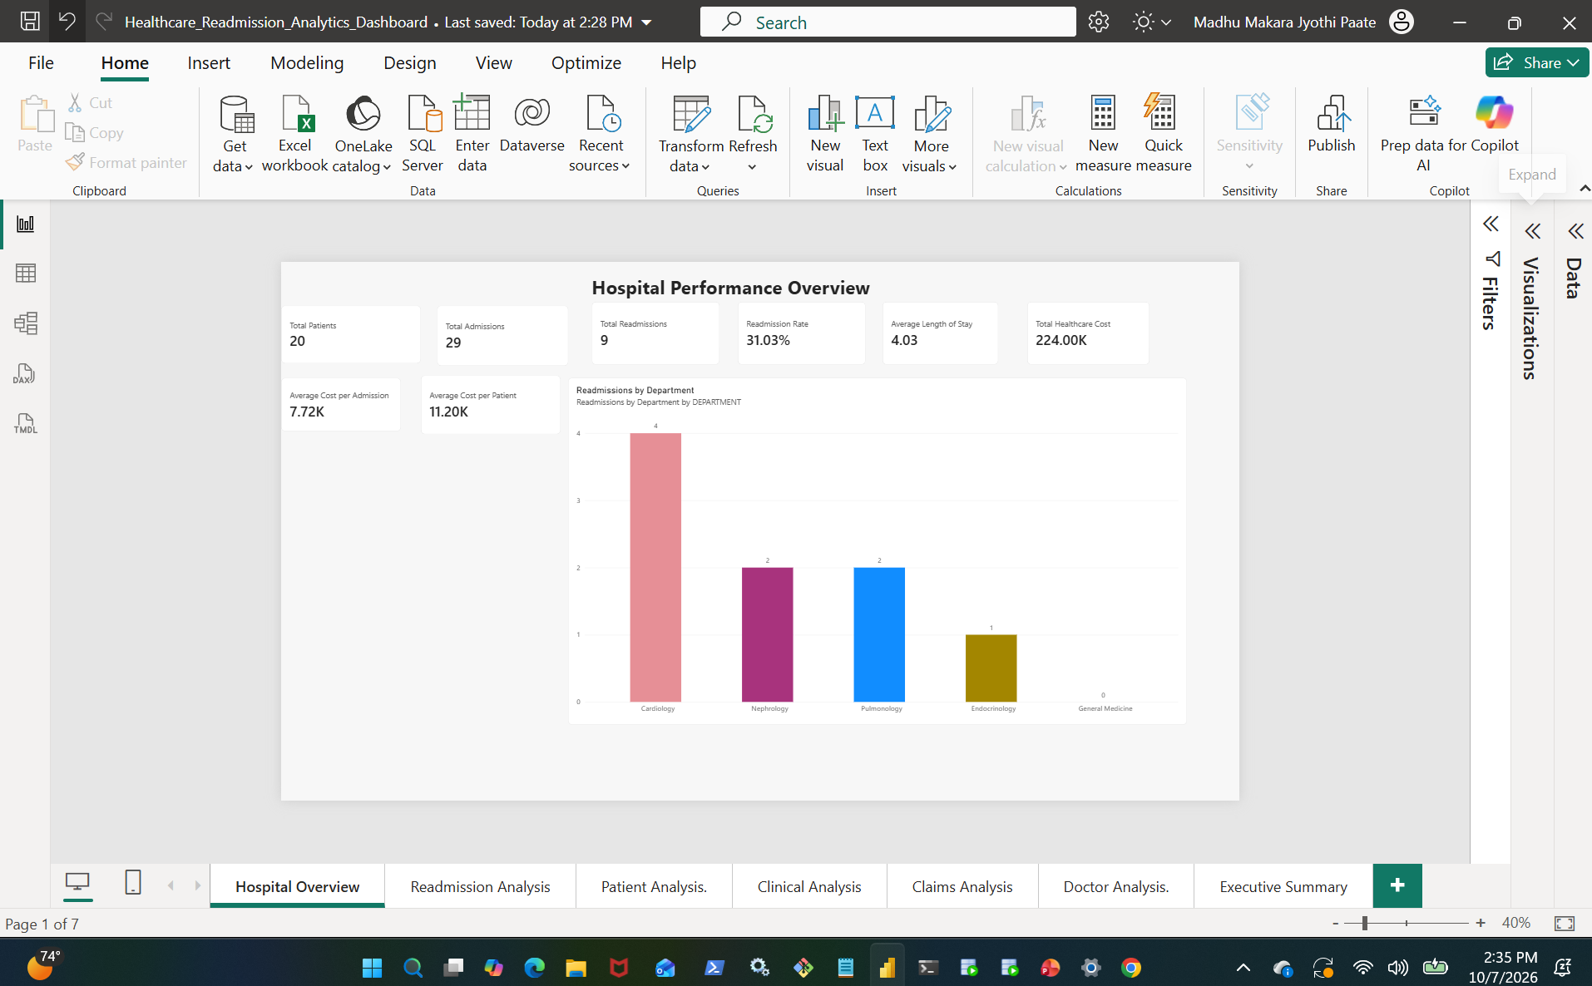
2. Readmission Analysis
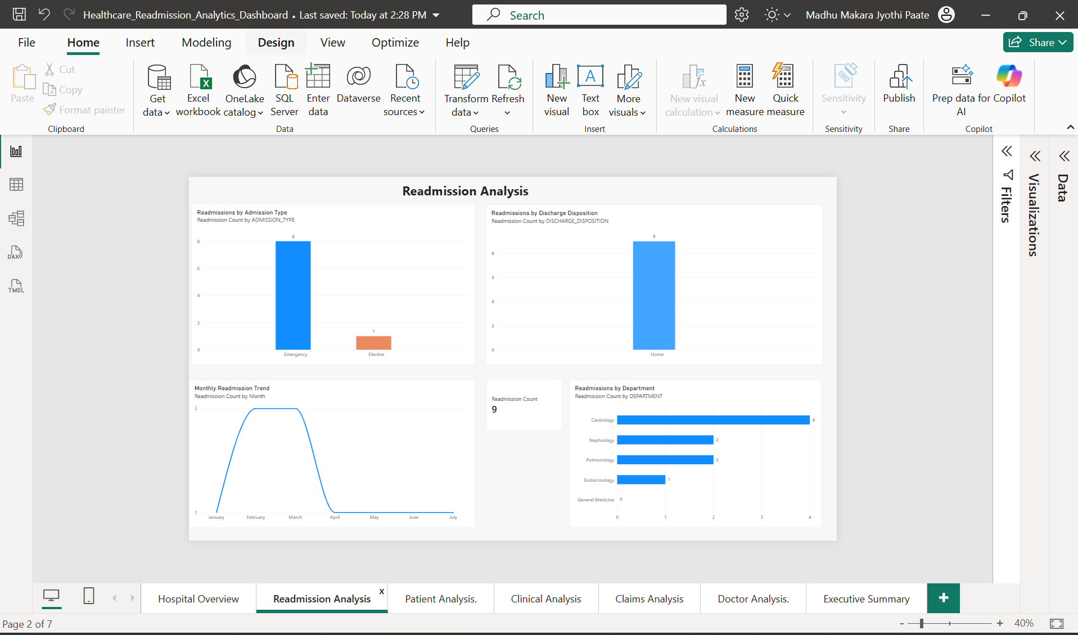
3. Patient Demographics & Clinical Analysis
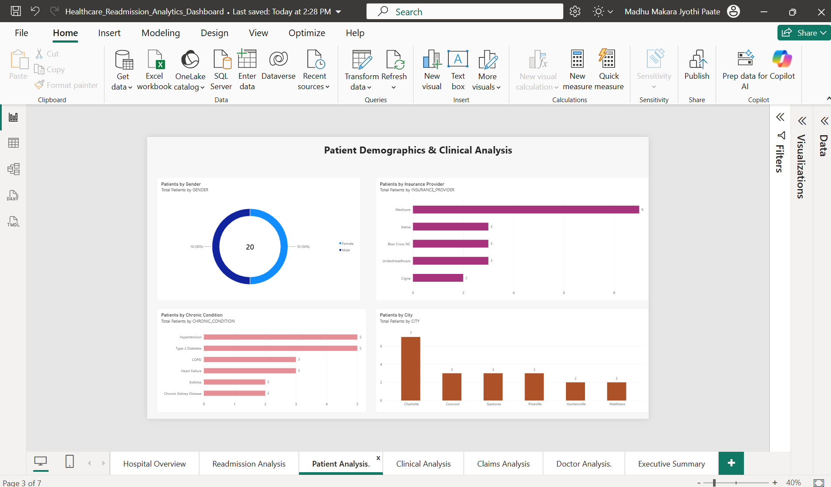

4. Clinical Outcomes & Diagnosis Analysis
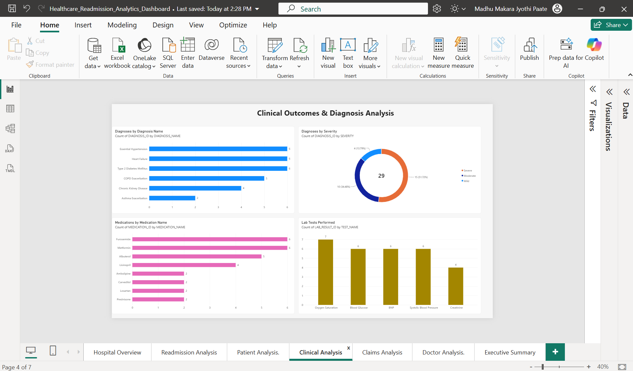
5. Healthcare Claims & Financial Analysis
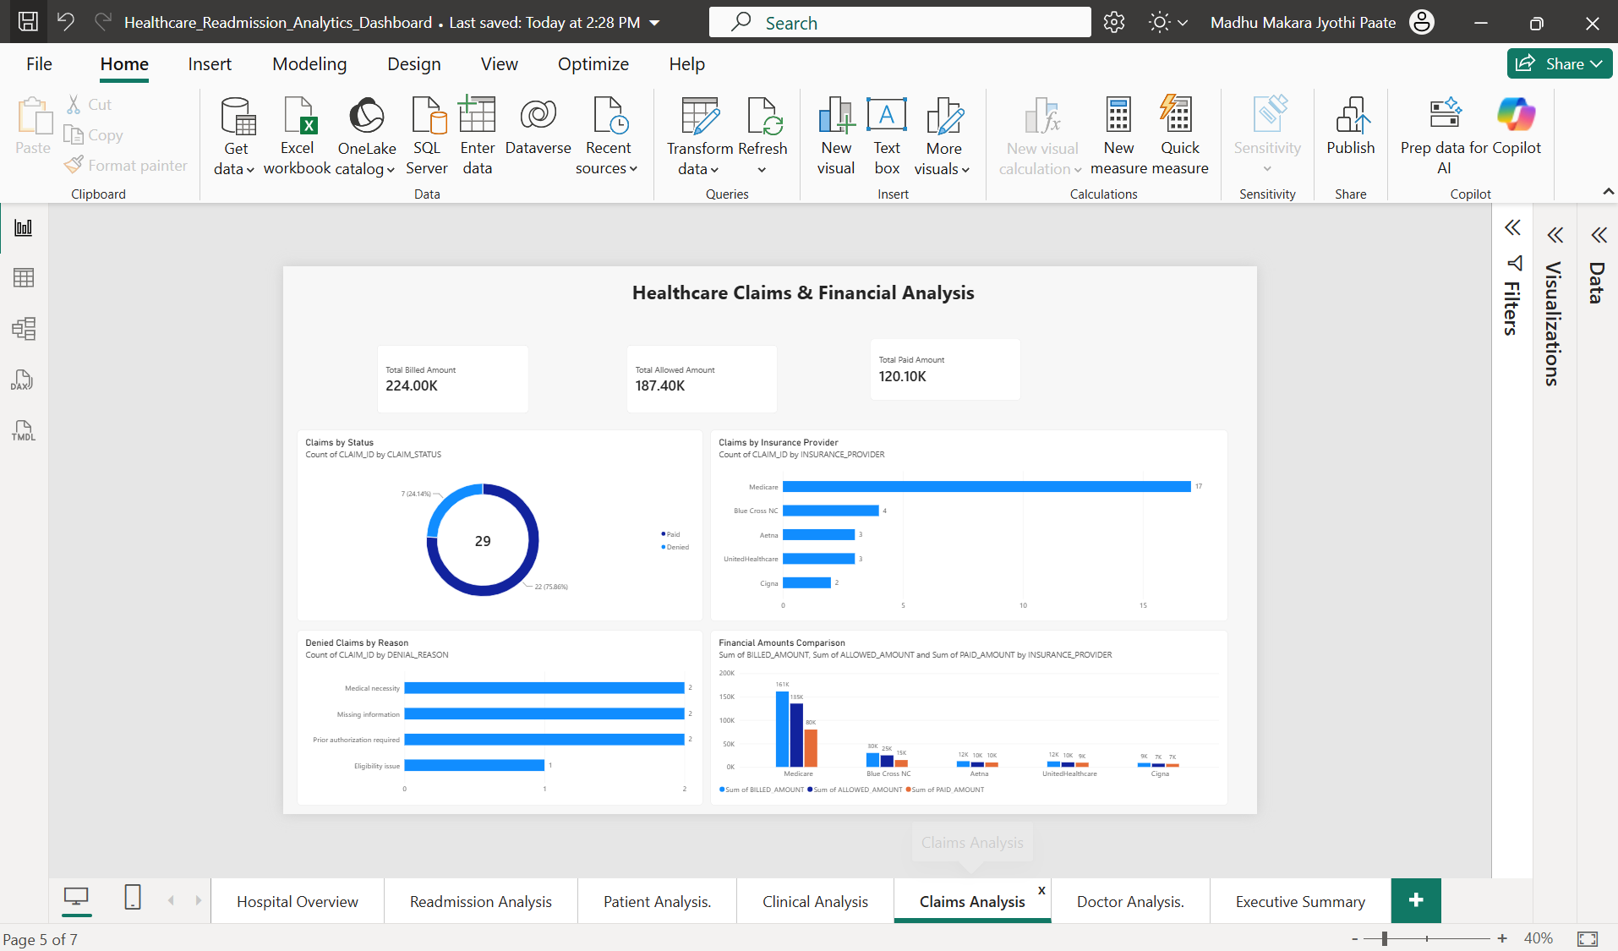
6. Doctor & Department Performance Analysis
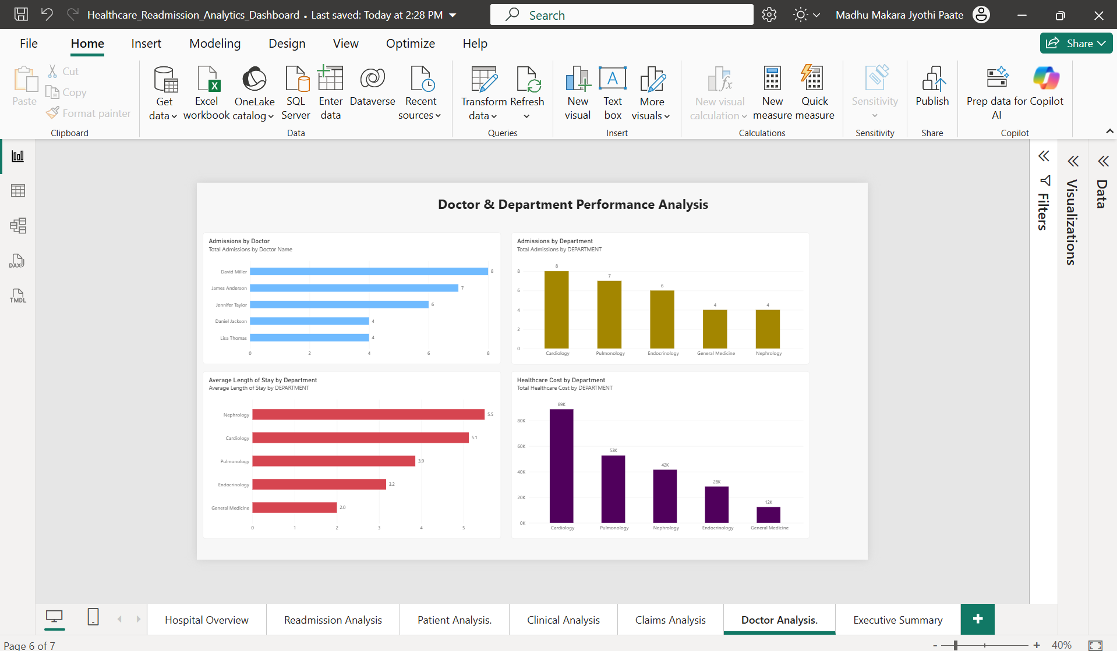

7. Healthcare Analytics Executive Summary
